SIMATS ENGINEERING
Department of Information Technology
CSA15 – CLOUD COMPUTING AND BIG DATA ANALYTICS

ASSIGNMENT 2 – CO2
Analyse, Evaluate and Validate a Virtualization Architecture for a Multi-Tenant University Private Cloud
CO2: Analyze virtualization architectures to identify performance and security issues in cloud computing environments.

Field | Details | Field | Details
Student Name |  | Register Number
Department / Section | Information Technology | Academic Year / Semester
Faculty Name |  | Nature of Assignment | Individual
Duration | 1 Week | Total Marks | 50
Submission Date |  | Evaluation Date

MARK SHEET (Rubric-based evaluation)

Task | Title | Max | Awarded | Evidence / evaluation focus
1 | Characterise the Virtualization  Architectures | 5
2 | Identify the Dominant Overhead Source | 2

Task | Title | Max | Awarded | Evidence / evaluation focus
3 | Build a Quantitative Performance Model | 6
4 | Analyse Performance Under Different Conditions | 4
5 | Security Threat and Vulnerability  Analysis | 3
6 | Formulate Isolation–Performance Trade-off | 3
7 | Evaluate Mitigation Strategies | 4
8 | Implement and Test | 4
9 | Record Experimental Performance | 3
10 | Compare Theory with Experiment | 4
11 | Recommend and Defend Final Architecture | 4
 | Day-4 Design Challenge | 8

TOTAL
50

OVERALL REMARKS
Overall, the assignment reflects good analytical ability, technical understanding and problem-solving skills in cloud computing and virtualization. The proposed architecture balances performance, security, resource efficiency and future scalability. The work can be further strengthened through verified experimental results, consistent benchmark comparisons and practical validation of the recommended security controls.

Student Signature | Faculty Signature | Program Director

MANDATORY SUBMISSION EVIDENCE CHECK
✓ = Present in documented answer; P = Partly present; X = Missing / not satisfied

Task | Evidence expected | Status | Evaluator note
1 | Three virtualization architectures, layered diagrams and trust boundaries
2 | Dominant overhead source identified and  explained for each approach
3 | CPU, memory, I/O, network and density models with assumptions
4 | Best, typical and worst operating-condition  analysis

Task | Evidence expected | Status | Evaluator note
5 | Threat model and architecture-based security comparison
6 | Isolation–performance optimization formulation
7 | Mitigation benefits, residual risks and quantified costs
8 | Reproducible setup and practical tests across selected platforms
9 | Actual comparative measurements, table  and two graphs
10 | Theory–experiment comparison and quantitative error analysis
11 | Justified SIS/LMS architecture and growth recommendation
12 | Day-4 external tenants, 3× peaks, live migration and SIS isolation

IMPLEMENTATION EVIDENCE CHAIN

Evidence item | Status | Observation
Architecture diagrams
Performance model

Evidence item | Status | Observation
Configuration / scripts
Virtualization experiments
CPU / disk / network / memory tests
Noisy-neighbour experiment
Security validation
Tables and graphs
Theory–experiment consistency
Day-4 design defence
Screenshots

SUBMISSION CHECKLIST (Not Separately Marked)

Requirement | Status
All 12 tasks answered | - Yes ☐ Partly ☐ No
Three virtualization approaches compared | - Yes ☐ Partly ☐ No
Layered diagrams and trust boundaries included | - Yes ☐ Partly ☐ No
Quantitative virtualization models included | - Yes ☐ Partly ☐ No
Threat analysis and mitigations included | - Yes ☐ Partly ☐ No

CLOUD COMPUTING AND BIG DATA

ASSIGNMENT 2
CO2: Analyze virtualization architectures to identify performance and security issues in cloud computing environments.

Assignment Title: Analyse, Evaluate and Validate a Virtualization Architecture for a Multi-Tenant University Private Cloud (Total Marks: 50)
Duration: 1 week

Scenario: EduCloud Virtualization Platform
A university runs a private cloud, EduCloud, in its data centre. EduCloud currently consists of:
- 16 physical hosts, each with 64 CPU cores, 512 GB RAM, NVMe SSD storage and 2 × 25 Gbps NICs
- About 400 virtual machines (VMs) running the Student Information System (SIS), the Learning Management System (LMS), the examination portal, and departmental research workloads
- A shared storage backend and a software-defined virtual network
During semester registration week, users report slow response times and failed logins. A recent internal security audit also found that VMs from different departments share the same physical hosts, that some VMs run outdated guest kernels, and that VM images are copied freely between teams.
You are the cloud architect. You must investigate, model, measure and compare virtualization architectures for EduCloud, identify their performance bottlenecks and security weaknesses, and recommend a design that remains practical as the platform grows.

Design Challenge:
The university now plans to host external research collaborators' big-data workloads (Spark/Hadoop clusters) on the same infrastructure as the SIS. Re-evaluate your design under these new multi-tenant conditions.

TASK 1: Characterise the Virtualization Architectures (5 Marks)
Select at least three meaningfully different virtualization approaches from the following, or justify others:
- Type-1 (bare-metal) hypervisor with full virtualization
- Type-2 (hosted) hypervisor
- Hardware-assisted virtualization vs. paravirtualization
- OS-level virtualization (containers)
- Lightweight/micro-VM or sandboxed container runtimes
Two configurations of the same hypervisor will not count as different approaches. Your selection must include at least one VM-based and at least one container-based approach.
For each approach, provide:
- A layered architecture diagram showing the hardware, host OS or hypervisor, guest OS, runtime and application
- The trust boundaries and the component that enforces isolation
- How CPU, memory, storage and network are virtualized
- A brief justification for why this approach is relevant to EduCloud
Evidence expected: Three architecturally distinct approaches with labelled diagrams, resource-virtualization mechanisms, trust boundaries, and justification of selection.

TASK 2: Identify the Dominant Overhead Source (2 Marks)
For each approach, identify the primary source of performance overhead that predominantly limits its performance (for example VM exits/traps, nested or extended page-table walks, virtual I/O emulation, virtual switch processing, or system-call interception).
Discuss:
- What the overhead source is
- Where in the architecture it occurs
- Why it is appropriate as the focus of performance analysis
- How its frequency or cost changes as the number of co-located VMs/containers or the I/O rate increases
Do not simply name a mechanism. Relate it to the behaviour of the architecture.

Evidence expected: A justified dominant-overhead identification for each approach, linked to its resource-virtualization path.

TASK 3: Build a Quantitative Performance Model (6 Marks)
Using the following host parameters, develop an analytical performance model for each approach.

Parameter | Value
Physical cores per host | 64
vCPU:pCPU overcommit ratio | 1:1, 2:1, 4:1, 8:1
RAM per host | 512 GB
Average VM memory demand | 8 GB
Cost of one VM exit (assume) | 1.5 µs
Native system-call cost (assume) | 0.2 µs
Network line rate | 25 Gbps

State and justify any additional assumptions. Derive expressions for:
- CPU: effective per-VM CPU capacity as a function of overcommit ratio and virtualization overhead (including steal time)
- Memory: the maximum number of VMs per host before ballooning, swapping or page-sharing becomes necessary
- I/O and network: effective throughput as a function of the number of VMs sharing the physical device
- Density: the number of VMs/containers a host can support while meeting a stated service-level target (for example, ≤ 10% performance degradation)
Show the mathematical reasoning. Merely quoting overhead percentages from the literature will not receive full credit.
Evidence expected: A clear mathematical derivation for each approach, with stated assumptions, parameter values and worked numerical examples.

TASK 4: Analyse Performance Under Different Operating Conditions (4 Marks)
Analyse how each approach behaves under three conditions:

- Best case: what workload and placement conditions minimise overhead?
- Typical case: for example, registration-week mixed web and database load
- Worst case: for example, noisy-neighbour interference, memory overcommit with swapping, live migration during peak load, or I/O storms
For each, explain what happens inside the virtualization layer, why the overhead changes, and how latency and throughput are affected. A table of numbers alone will not be accepted.
Evidence expected: A justified condition-based analysis supported by your Task 3 model.

TASK 5: Security Threat and Vulnerability Analysis (3 Marks)
Construct a threat model for each approach. Discuss:
- The attack surface (hypervisor, device emulation, shared kernel, management plane, VM images and snapshots, virtual network)
- At least four distinct threat categories, such as VM escape, cross-VM side-channel attacks, hypervisor or container-runtime vulnerabilities, VM
sprawl and unpatched guests, image tampering, insecure live migration, and virtual-network sniffing or spoofing
- For each threat, which approach is more or less exposed and why, referring to its architecture and trust boundaries
- The likely impact on the confidentiality, integrity and availability of student records
Evidence expected: A structured threat model mapped to architectural features, with a justified comparison across approaches.

TASK 6: Formulate the Isolation–Performance Trade-off (3 Marks)
Formalise the trade-off between isolation strength and performance/density for EduCloud.
Clearly identify:
- The decision variables (for example, approach chosen, VMs per host, dedicated vs. shared hosts, SMT on/off)
- The objective(s), such as maximising density or minimising cost

- The constraints (for example, performance degradation limit, isolation requirement for SIS, available hosts)
- How these components combine into a cost or decision function
The formulation must follow from your own analysis in Tasks 3 and 5, not from a generic template.
Evidence expected: A clearly defined trade-off model with identified variables, objective and constraints.

TASK 7: Evaluate Mitigation Strategies (4 Marks)
Propose at least three mitigations for the vulnerabilities identified in Task 5. Examples include disabling SMT, kernel page-table isolation, dedicated hosts for sensitive tenants, secure or sandboxed container runtimes, hardware memory encryption, image signing, and micro-segmentation.
For each mitigation, discuss:
- Why it is applicable to the threat
- What residual risk remains
- The performance or density cost, estimated using your Task 3 model
- Whether the trade-off is acceptable for the SIS
Evidence expected: Mitigations evaluated analytically, with their security benefit and quantified performance cost.

TASK 8: Implement and Test (4 Marks)
Build a test environment and experimentally test all selected approaches.
- Platforms: use any open-source stack, for example KVM/QEMU, Xen or VirtualBox, Docker/Podman, and Kata Containers or gVisor. Nested virtualization on a laptop is acceptable if documented.
- Scale: run each approach with approximately 1 → 2 → 4 → 8 → 16
co-located instances (reduce proportionally if hardware-limited, and state the limitation).
- Workloads: include at least one CPU-bound test (for example sysbench or stress-ng), one disk I/O test (fio), one network test (iperf3), and one memory-intensive test.
- Interference test: run at least one noisy-neighbour experiment.

- Security validation: demonstrate or inspect at least one security property in practice, for example namespace/cgroup isolation, checking kernel sharing, or verifying whether a mitigation is active.
Ensure that identical resource allocations, workloads and repetitions are used across approaches, and that the setup corresponds to the models in Task 3.
Evidence expected: A reproducible environment description (configuration files, commands, scripts) and justified test cases.

TASK 9: Record Experimental Performance (3 Marks)
Collect and present data such as:
- Throughput, latency (mean and 95th percentile), CPU steal time, context switches and VM exits where observable
- Instance start-up time and memory footprint per instance
- Performance degradation versus a bare-metal baseline
- Results with and without at least one security mitigation
Present at least one table and two graphs (for example, throughput versus number of instances, and latency under interference). Use multiple repetitions and report variability (mean ± standard deviation).
Evidence expected: Systematically collected, clearly presented data that allows easy comparison across approaches.

TASK 10: Compare Theory with Experiment (4 Marks)
Compare your Task 3 and Task 4 predictions with Task 9 measurements. Discuss:
- Whether the observed degradation trends agree with your model
- Which approach scales better as co-located instances increase
- Quantitative differences between predicted and measured values, and plausible causes (for example caching effects, hypervisor scheduler behaviour, nested virtualization, laptop hardware, or unmodelled I/O paths)
- Whether any measured result changes your security conclusions from Task 5
Interpret the results; do not simply reproduce tables.
Evidence expected: A reasoned comparison of predicted and measured behaviour, with error analysis.

TASK 11: Recommend and Defend the Final Architecture (4 Marks)
Recommend the virtualization architecture (or hybrid) for EduCloud's SIS and LMS workloads.
Discuss:
- Which approach you recommend and why it is more appropriate than the alternatives
- Its modelled and experimentally observed performance
- Its security posture and residual risks
- Operational costs such as patching, image management, migration and monitoring
- Limitations and trade-offs
- Whether it remains practical as EduCloud grows from 400 to several thousand instances
Your recommendation must rest on your own analysis and experiments. Choosing "the most secure" or "the fastest" option alone is not sufficient.
Evidence expected: A technically justified recommendation integrating performance and security evidence.

DAY-4 DESIGN CHALLENGE

TASK 12: Re-evaluate and Adapt the Design (8 Marks)

Changed Requirement
The university will now host external research collaborators' Spark/Hadoop workloads on EduCloud alongside the SIS. The new conditions are:
- Big-data jobs are I/O- and network-intensive and run for hours
- Registration-week peak load is about 3× normal
- Hosts are sometimes patched using live migration of running VMs
- A data-protection regulation now requires demonstrable isolation of student records from external tenants
You may RETAIN → MODIFY → or REDESIGN your original solution.

Impact Analysis (2 Marks)
Discuss what has changed, which original assumptions (trusted tenants, workload mix, I/O profile) no longer hold, and how mixing batch big-data workloads with latency-sensitive SIS workloads changes both the performance and the threat model.

Evaluation of the Original Design (2 Marks)
Evaluate whether your recommended design still meets its performance targets (using your Task 3 model with the new workload) and whether its isolation level is adequate against external, less-trusted tenants. Consider whether another architecture could do better overall.

Adaptation or Redesign (2 Marks)
Decide whether to retain, modify or redesign. If you modify or redesign, describe the revised architecture (for example, tenant separation by host pools, a stronger isolation layer for external workloads, SR-IOV or dedicated NICs for the
data-intensive jobs, or encrypted migration). Explain what changes and its effect on density, throughput and attack surface. If you retain, justify why no change is required.

Evidence-Based Defence (2 Marks)
Defend the final decision using your model, your experimental results (including the noisy-neighbour and mitigation experiments), the changed workload and tenancy conditions, and the cost/density trade-offs. The decision must follow logically from the analysis.

MARK DISTRIBUTION

Task | Marks
Task 1 – Architecture Characterisation | 5
Task 2 – Dominant Overhead Identification | 2
Task 3 – Quantitative Performance Model | 6
Task 4 – Performance Under Operating Conditions | 4
Task 5 – Security Threat and Vulnerability Analysis | 3
Task 6 – Isolation–Performance Trade-off Formulation | 3

Task 7 – Mitigation Evaluation | 4
Task 8 – Implementation and Testing | 4
Task 9 – Experimental Performance | 3
Task 10 – Theory vs. Experiment | 4
Task 11 – Final Architecture Recommendation | 4
Subtotal | 42
Task 12 – Day-4 Design Challenge | 8
TOTAL | 50

TASK 1: Characterise the Virtualization Architectures (5 Marks)
Four architecturally different approaches are selected. Together they cover VM-based (A, D) and container-based (B, C) designs, and each has a different component enforcing isolation.

ID | Approach | Category | Why it is meaningfully different
A | Type-1 / KVM full virtualization, hardware-assisted (VT-x, EPT, virtio) | VM-based | Guest has its own kernel; hypervisor + hardware enforce isolation
B | OS-level containers (Docker / runc) | Container-based | No guest kernel; one shared host kernel enforces isolation
C | Sandboxed container (gVisor / runsc) | Container-based (sandboxed) | User-space kernel (Sentry) sits between app and host kernel
D | Micro-VM container (Kata Containers on KVM) | VM-based (lightweight) | Container UX but each pod runs in its own tiny VM

Layered architecture diagrams with trust boundaries
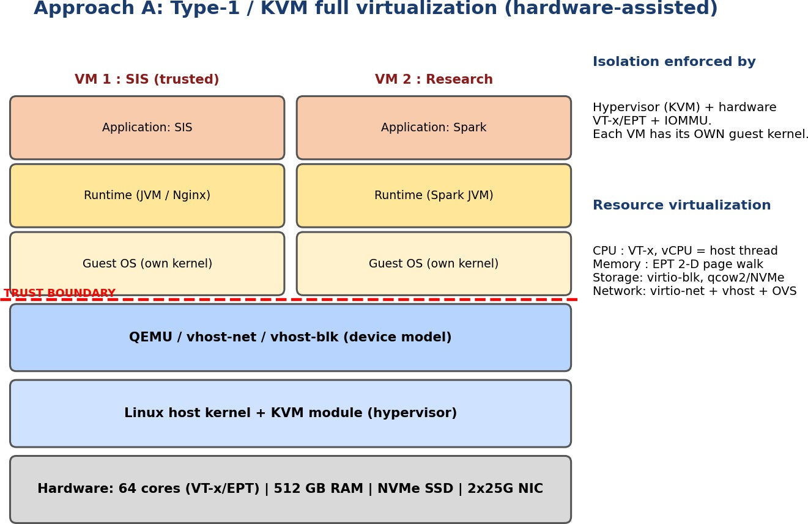
Figure 1: Approach A – KVM full virtualization (layers, trust boundary, isolation enforcer)

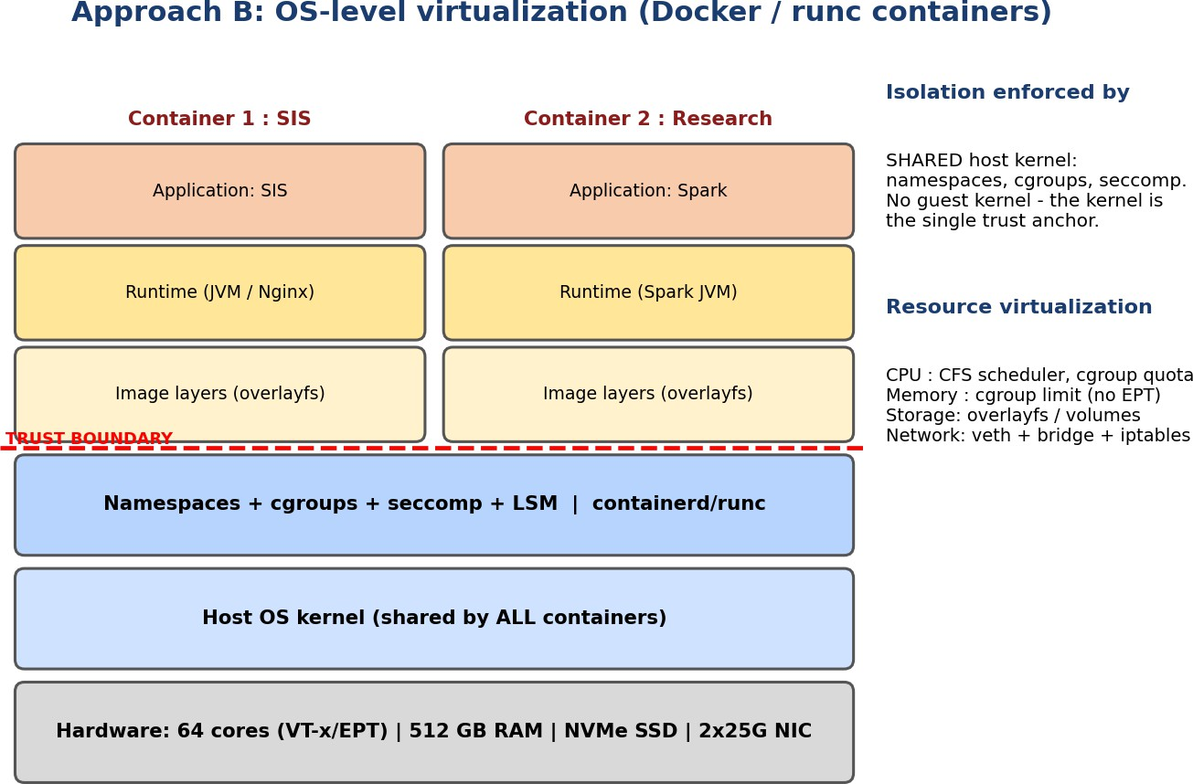

Figure 2: Approach B – Docker / runc containers
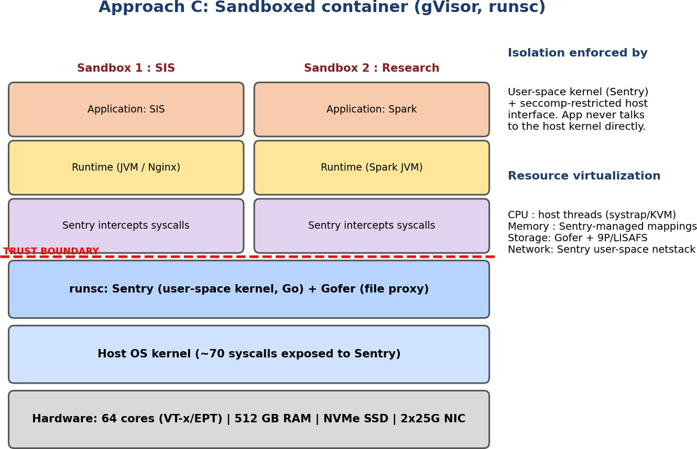

Figure 3: Approach C – gVisor sandboxed container

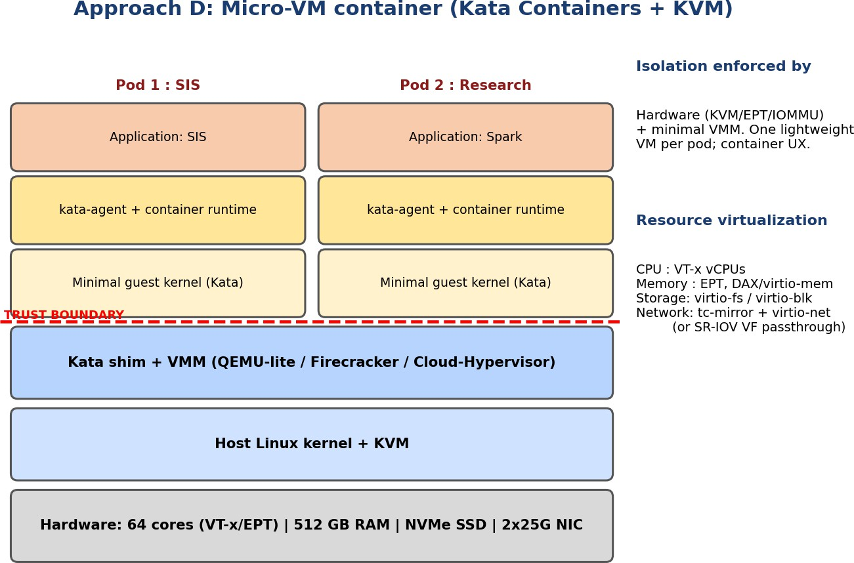

Figure 4: Approach D – Kata Containers (micro-VM)

Trust boundaries, isolation enforcer and resource virtualization

Aspect | A: KVM VM | B: Docker | C: gVisor | D: Kata
Trust boundary | Between guest kernel and host (VM exit interface, device emulation) | Between container process and the shared host kernel (syscall interface) | Between app and Sentry, and again Sentry to host (~70 syscalls) | Between guest kernel in micro-VM and host (VM exit interface)
Isolation enforced by | KVM + VT-x/EPT + IOMMU | Namespaces, cgroups, seccomp, LSM (all in host kernel) | Sentry (user-space kernel) + seccomp on Sentry | KVM/EPT + minimal VMM
CPU | vCPU = host thread, scheduled by host CFS; VM exits on privileged events | Processes under CFS with cgroup quota/shares; no trapping | Host threads; every syscall trapped to Sentry | vCPU threads as in A
Memory | Guest page tables + EPT (2-D walk); ballooning, KSM | cgroup memory limit; native page tables | Sentry-managed mappings over host memory; cgroup limit | EPT; virtio-mem/DAX to save memory
Storage | virtio-blk / qcow2 on NVMe | overlayfs / bind volumes (native speed) | Gofer proxy + LISAFS (RPC per file op) | virtio-fs or virtio-blk
Network | virtio-net + vhost + OVS | veth + Linux bridge + iptables/conntrack | Sentry user-space netstack (or host-network mode) | virtio-net via tc-mirror, or SR-IOV VF

Relevance to EduCloud
    - A (KVM): the proven choice for the SIS/LMS; separate guest kernels, mature live migration, and it matches the existing estate of ~400 VMs.
    - B (Docker): highest density and fastest start-up; relevant for trusted, stateless services such as the LMS web tier and dev/test of departments.
    - C (gVisor): reduces the host-kernel attack surface for untrusted code without a full VM; relevant as a candidate for external collaborators.

    - D (Kata): gives VM-grade isolation with container workflow (images, Kubernetes); the strongest candidate for external Spark/Hadoop tenants (Task 12).

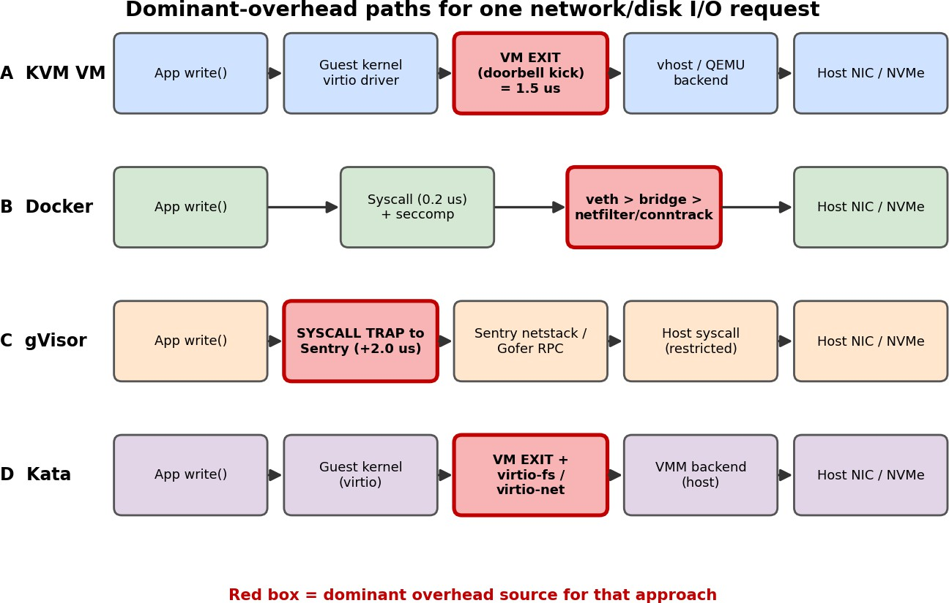
TASK 2: Identify the Dominant Overhead Source (2 Marks)

Figure 5: Path of one I/O request through each approach; the red box is the dominant overhead

Approach | Dominant overhead | Where it occurs | Why it is the right focus | How it scales
A: KVM | VM exits (privileged instructions, virtio doorbell kicks, interrupts); the EPT 2-D walk is secondary | Between guest kernel and KVM; every exit costs 1.5 µs of lost guest time | Exit cost is the one hardware-defined tax every guest pays; exit rate is the quantity that changes with load | Cost = λ_exit·t_exit. λ_exit = λ_base + 1.5·R, so it rises linearly with I/O rate. At 25 Gbps (2.03 Mpps) without batching: 3.05 cores of exit time; with virtio batching b = 32:  0.095 core
B:  Docker | Virtual-switch processing: veth, bridge and netfilter/conntrack per packet, plus shared-kernel lock contention | Host kernel network stack between container and NIC | CPU path is native (no trapping), so the network and filesystem path are what remain | Per-packet cost c_io is fixed, but conntrack tables and the shared bridge grow with the number of containers: κ·log2(n) loss
C: gVisor | System-call interception (trap to Sentry) | Every syscall of the app is redirected to the user-space kernel | Syscall rate decides everything: native 0.2 µs becomes about 2.2 µs (11×) | Overhead = λ_sys·t_gv. At 50,000 syscalls/s it is 10% per core and grows linearly with I/O rate (more I/O means more syscalls)

Approach | Dominant overhead | Where it occurs | Why it is the right focus | How it scales
D: Kata | VM exits + virtio-fs / virtio-net path (host-guest file and network sharing) | Guest kernel ↔ VMM ↔ host for each file and packet operation | Container-style workloads are I/O heavy; the extra file-sharing layer is added on top of exits | Exit cost as in A plus 2% for file sharing. With SR-IOV the network exit path is bypassed, so cost falls sharply (Task 12)

TASK 3: Build a Quantitative Performance Model (6 Marks)
Key insight: the dominant overhead depends on the architecture's resource-virtualization path. VMs pay at the hardware boundary (exits), containers pay in the shared kernel (network/cgroup path), and sandboxed runtimes pay at the system-call boundary. The overhead therefore grows with I/O rate for A, C, D and with co-location density for B.

CPU model: effective per-VM capacity with steal time
Let r be the vCPU:pCPU overcommit ratio. A host with P = 64 cores exposes 64·r vCPUs, so a busy vCPU is entitled to a fair share 1/r of a physical core.
Step 1: virtualization overhead (exit + EPT):
o_exit = λ_exit · t_exit o_virt = 1 − (1 − o_exit)(1 − o_ept)
For KVM: o_exit = 14,000 × 1.5 µs = 2.1%, o_ept = 3%, so o_virt = 1 − 0.979 × 0.97 = 5.04%. For gVisor: o_virt = λ_sys · t_gv = 50,000 × 2.0 µs = 10%. For Docker (cgroup accounting, seccomp, overlayfs) assumed 2%. For Kata: 1 − 0.979 × 0.97 × 0.98 = 6.94%.
Step 2: scheduling overhead and steal time. If each vCPU is busy a fraction u of the time, total demand is r·u cores per core. The steal time is the fraction of runnable time a vCPU waits:
steal(r,u) = max(0, 1 − 1/(r·u)) σ(r) = s·(r − 1)
Step 3: effective capacity of one fully busy vCPU (in physical-core equivalents):
C_vcpu(r) = (1/r) · (1 − σ(r)) · (1 − o_virt)
Worked example (KVM, r = 4): σ = 0.004 × 3 = 1.2%; C = 0.25 × 0.988 × 0.9496 = 0.2346, i.e. 6.2%
below the ideal fair share of 0.25. If u = 0.5, steal = 1 − 1/(4 × 0.5) = 50%; if u = 0.25 steal is 0 because demand fits.

Overcommit r | Ideal 1/r | KVM | Docker | gVisor | Kata
1:1 | 1.0000 | 0.9496 | 0.9800 | 0.9000 | 0.9306
2:1 | 0.5000 | 0.4729 | 0.4890 | 0.4486 | 0.4635
4:1 | 0.2500 | 0.2346 | 0.2435 | 0.2230 | 0.2299
8:1 | 0.1250 | 0.1154 | 0.1208 | 0.1101 | 0.1131

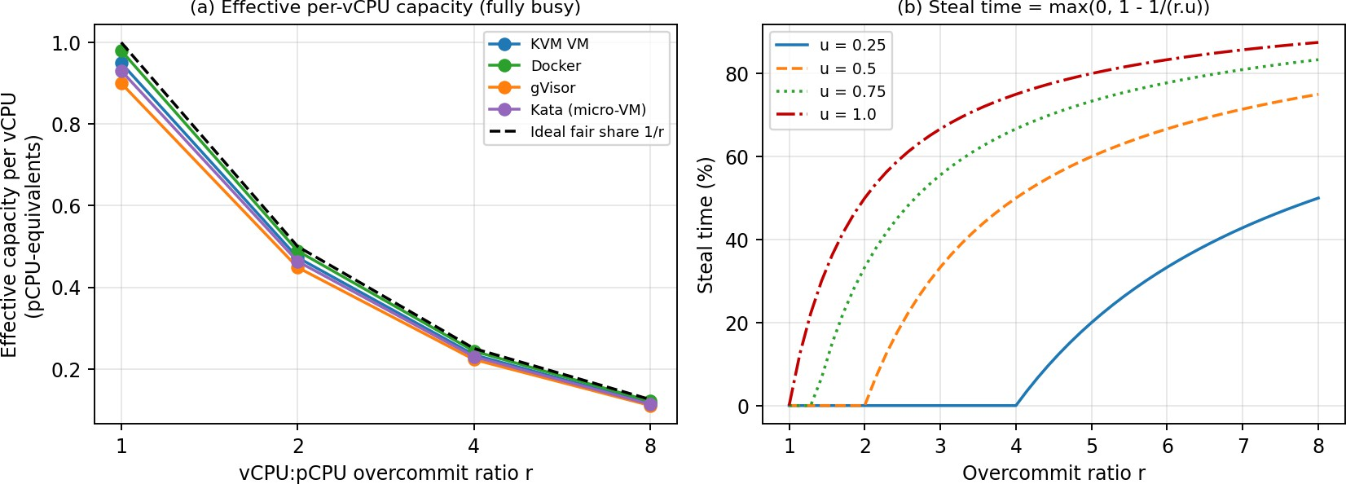
Figure 6: (a) Effective capacity per vCPU vs overcommit; (b) steal time vs overcommit for different utilisations

Memory model: maximum VMs per host
N_mem = floor( (M − M_reserve) / (m + m_overhead) )
KVM: (512 − 16) / (8 + 0.4) = 59.05, so N_mem = 59. Docker: (512 − 8) / 8.05 = 62.6, so 62. gVisor: 504 /
8.15 = 61.8, so 61. Kata: 496 / 8.25 = 60.1, so 60.
Beyond N_mem, memory reclaim is required. With page sharing (KSM) of fraction φ = 15% of identical guest pages: N = 496 / (0.4 + 8 × 0.85) = 68. With ballooning to a 70% working set: N = 496 / (0.4 + 5.6) =
82. Beyond that the host swaps, and the effective memory access time becomes:
EMAT = (1 − p)·t_mem + p·t_swap (t_mem = 100 ns, t_swap = 100 µs)
p = 10⁻⁴ gives 110 ns (1.1×), p = 10⁻³ gives 200 ns (2×), p = 10⁻² gives 1.1 µs (11×). Swapping must therefore be avoided on the SIS hosts.

I/O and network model
Important consequence: with 8 GB instances the memory limit (≈ 59 per host) is reached at r = 3.7 for 4-vCPU VMs. The 8:1 ratio would need 128 VMs × 8 GB = 1 TB, which is not feasible without memory overcommit. Memory, not CPU, caps density at high r.
The NIC is shared by n instances with protocol/path efficiency η and a contention loss κ·log2(n) (vSwitch lock contention, conntrack, queue interference):
T_inst(n) = η · L · (1 − κ·log2 n) / n
Assumed η: KVM 0.92 (vhost-net), Docker 0.95 (veth+bridge), gVisor 0.45 (user-space netstack, about 11 Gbps ceiling), Kata 0.90. κ: 0.010, 0.015, 0.020, 0.010 respectively.

n sharing 25 Gbps | KVM | Docker | gVisor | Kata | Ideal L/n
1 | 23.00 | 23.75 | 11.25 | 22.50 | 25.00
2 | 11.38 | 11.70 | 5.51 | 11.14 | 12.50
4 | 5.63 | 5.76 | 2.70 | 5.51 | 6.25
8 | 2.79 | 2.84 | 1.32 | 2.73 | 3.13
16 | 1.38 | 1.40 | 0.65 | 1.35 | 1.56
32 | 0.68 | 0.69 | 0.32 | 0.67 | 0.78
Worked example (KVM, n = 4): T = 0.92 × 25 × (1 − 0.01 × 2) / 4 = 5.63 Gbps per VM (ideal 6.25).
Backend CPU cost of I/O: each instance doing R ops/s consumes R·c_io of a core in backend threads. Total backend load on the host: U_io(N) = N·R·c_io. For KVM with N = 25: 25 × 10,000 × 6 µs = 1.5 cores (2.3% of 64).

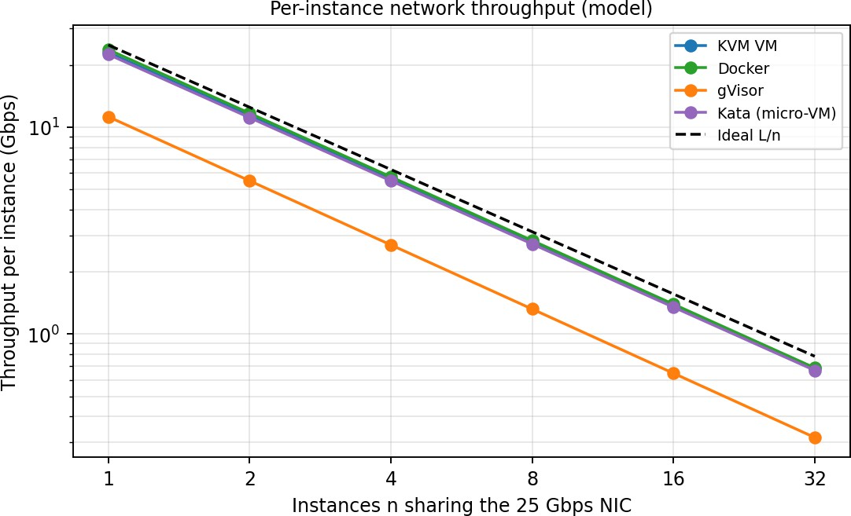
Figure 7: Network throughput per instance vs number of instances (log–log)

Density model: instances per host under an SLO
Combining the CPU, backend-I/O and scheduling terms, the degradation relative to a dedicated core share is:
D(N) = 1 − (1 − N·R·c_io/P) · (1 − σ(r)) · (1 − o_virt), r = N·v/P
The density is the largest N satisfying D(N) ≤ SLO and N ≤ N_mem.
Worked example (KVM, N = 25): backend = 25 × 10⁴ × 6 µs / 64 = 2.34%; r = 1.5625, σ = 0.225%; D = 1
− 0.9766 × 0.99775 × 0.9496 = 7.5%, which meets the 10% SLO. At N = 47: D = 9.9% (limit). At N = 59:
11.3%, which fails.

Approach | o_virt | N_mem | Density at D ≤ 10% | Density at D ≤ 20%
KVM VM | 5.04% | 59 | 47 | 59
Docker | 2% | 62 | 62 | 62
gVisor | 10% | 61 | 0 (infeasible: o_virt alone ≥ 10%) | 55
Kata (micro-VM) | 6.94% | 60 | 27 | 60

Degradation as overcommit rises (N = 64·r/4 instances; values marked * exceed the memory limit and need ballooning/KSM):

r | N | KVM D% | Docker D% | gVisor D% | Kata D%
1:1 | 16 | 6.5 | 3 | 12.7 | 8.6
2:1 | 32 | 8.3 | 4.2 | 15.7 | 10.6
4:1 | 64 | 11.8* | 6.5* | 21.5* | 14.5*
8:1 | 128 | 18.8* | 11.1* | 33* | 22.2*

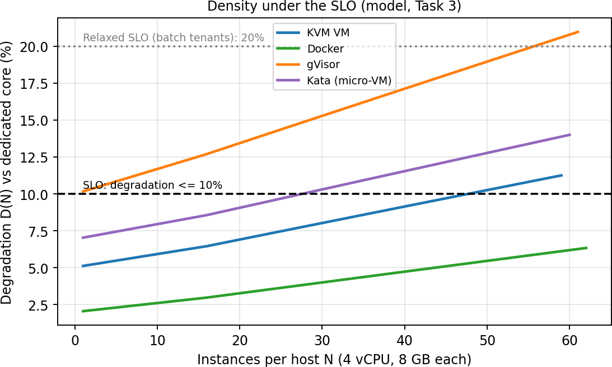
Figure 8: Degradation vs density; KVM reaches the 10% SLO at 47 VMs/host
Reading the result: Docker is memory-limited (62), KVM is SLO-limited (47), Kata is limited by virtio-fs/exit costs (27), and gVisor cannot meet a 10% SLO for syscall-heavy SIS workloads at all (but reaches 55 under the relaxed 20% target for batch tenants).

TASK 4: Analyse Performance Under Different Operating Conditions (4 Marks)
Model degradation D (Task 3) under three conditions. Best: r = 1, 16 instances, huge pages, light I/O (R = 1,000/s). Typical: registration week, N = 25 per host, R = 10,000/s. Worst: noisy neighbour I/O storm (R = 40,000/s) at N = 25.

Approach | Best case D% | Typical D% | Worst case D%
KVM VM | 2.3 | 7.5 | 14.1
Docker | 0.6 | 3.6 | 8.2
gVisor | 2.3 | 14.4 | 27
Kata (micro-VM) | 2.8 | 9.7 | 17.3

What happens inside the virtualization layer

A: KVM full VM
    - Best: vCPUs pinned 1:1 and backed by huge pages. The EPT walk is cheap (TLB reach is large, o_ept
≈ 1%), exits are limited to timers (λ ≈ 8,000/s, 1.2%), so D ≈ 2.3%. Latency is near native; throughput is limited by the application.
    - Typical: web + DB mix. Each I/O kick causes exits and vhost threads consume 2.3% of host CPU. At peak 3× load (u = 0.75, r = 1.56) steal = 1 − 1/(1.56 × 0.75) = 14.7%, so request queues build up. This matches the slow responses and failed logins reported in registration week.
    - Worst: an I/O storm lifts the exit and backend load (D = 14.1%); vhost threads compete with vCPU threads for the same cores, so p95 latency rises (≈1.25× from the interference model, Fig. 14b). Memory overcommit with swapping: p = 10⁻³ doubles memory latency. Live migration during peak: pre-copy time T = M/(B − d) = 8/(1.56 − 0.4) = 6.9 s, but each iteration write-protects pages

(extra EPT faults) and uses half the NIC, reducing SIS network throughput by up to 50% during migration.

B: Docker containers
    - Best: CPU-bound, no trapping, native page tables: D ≈ 0.6%. Fastest start-up (<1 s).
    - Typical: only the veth/bridge/conntrack and cgroup accounting costs remain: D = 3.6%. Density is limited by memory, not CPU.
    - Worst: all containers share one kernel, so a noisy neighbour contends for the same run queues, page cache, block queue and conntrack table. The model overhead is still modest (8.2%) but the interference is the highest (1.67× p95) because the leak coefficient is 0.5 (no hardware-enforced separation of queues). Memory pressure triggers the host OOM killer instead of guest swapping.

C: gVisor
    - Best: compute-bound code with few syscalls (10,000/s): D ≈ 2.3%.
    - Typical: syscall-heavy web/DB: every syscall becomes ≈2.2 µs instead of 0.2 µs, D = 14.4%; the user-space netstack caps one sandbox at about 11 Gbps.
    - Worst: I/O storm raises syscall rate and Gofer RPCs, D = 27%; Sentry becomes a CPU bottleneck. Latency suffers more than throughput because each syscall is serialised through Sentry threads.

D: Kata micro-VM
    - Best: D ≈ 2.8% with pinned vCPUs and DAX/virtio-mem.
    - Typical: exits + virtio-fs file sharing: D = 9.7% (just inside the SLO at N = 25).
    - Worst: D = 17.3% on virtio path, but the VM boundary keeps interference low (1.19×). Using SR-IOV for the network removes most of the host-side cost (Task 12).
Link to Task 3: each number above is produced by D(N) with the condition-specific parameters (R, λ, o_ept, N); the mechanisms explain why those parameters change. A table of numbers alone is not the argument; the mechanism column is.

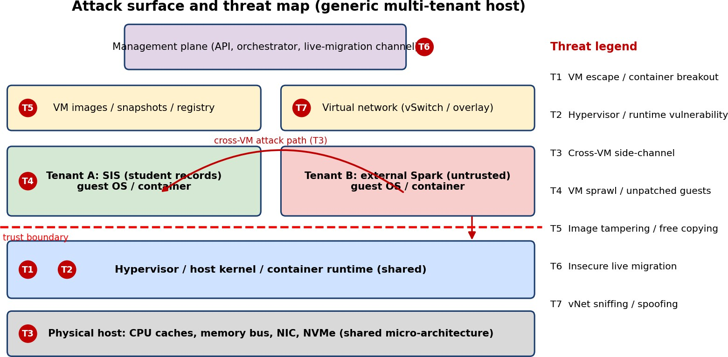
TASK 5: Security Threat and Vulnerability Analysis (3 Marks)

Figure 9: Attack surface and the seven threat categories mapped to architecture layers

Attack surface per approach

Surface | A: KVM | B: Docker | C: gVisor | D: Kata
Hypervisor / kernel | KVM module (~small), but QEMU device emulation is large | Entire host kernel (≈ 400+ syscalls) | Sentry (Go, memory-safe) + about 70 host syscalls | KVM + minimal VMM (Firecracker-style)
Device emulation | Large (QEMU) unless virtio-only | None | None (no virtual devices) | Small, virtio only
Shared kernel | No (guest kernel per VM) | Yes, all tenants | No (Sentry per sandbox) | No (guest kernel per pod)
Management plane | libvirt/OpenStack API | Docker/containerd socket (root-equivalent) | runsc + containerd | kata-shim + containerd/K8s
Images / snapshots | qcow2 copies, snapshots hold RAM | Layered images, content-addressed digests | Same as Docker | Container images + guest kernel image
Virtual network | OVS / Linux bridge | Shared bridge by default | Own netstack per sandbox | tap + tc-mirror per pod

Threat categories and comparative exposure

Threat | Why it matters / mechanism | Most exposed | Least exposed and why
T1 VM escape / container breakout | Attacker in one tenant gains code execution on the host | Docker: one kernel bug breaks the namespace boundary | KVM and Kata: must defeat hypervisor + EPT + VMM
T2 Hypervisor / runtime vulnerability | Bug in KVM, QEMU, runc, containerd or Sentry | Docker (huge kernel attack surface, runc CVEs) | gVisor: small host interface, memory-safe code
T3 Cross-VM side-channel (Spectre, L1TF, cache timing) | Co-located tenants share caches, SMT siblings, branch predictors | Docker (shared kernel structures + caches) | No approach is immune; all share hardware. Dedicated hosts and SMT off are the only full cure
T4 VM sprawl / unpatched guests | Each VM has its own kernel and image to patch (found in the audit) | KVM: 400 guest kernels to patch | Docker: one host kernel to patch; Kata/gVisor: guest kernel managed centrally
T5 Image tampering / free copying | Altered or leaked golden image, qcow2 copies between teams | KVM (large mutable images, no signatures) | Containers: content-addressed layers can be signed and verified
T6 Insecure live migration | Guest RAM (including student records) crosses the network in plaintext | KVM and Kata (RAM pre-copy) | Docker/gVisor: no live migration of state (restart instead)
T7 Virtual-network sniffing / spoofing | ARP/MAC spoofing, packet capture on shared bridge | Docker (shared bridge, CAP_NET_RAW) | gVisor/Kata: per-sandbox netstack or tap isolates L2

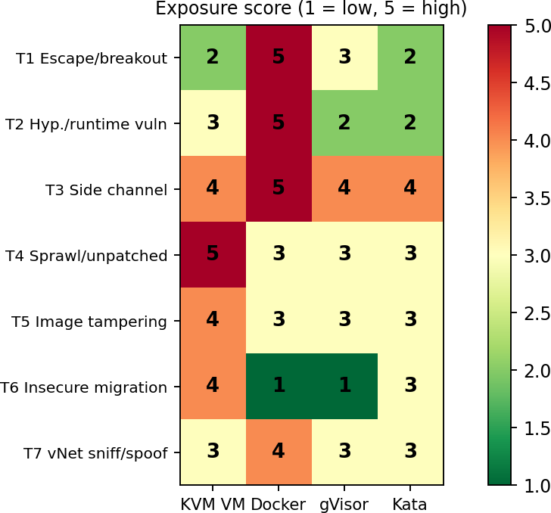
Figure 10: Exposure scores (1–5) per threat and approach, derived from the table above

Impact on confidentiality, integrity and availability of student records

Threat | Confidentiality | Integrity | Availability
T1 / T2 escape, runtime bug | High: read all tenant memory and storage | High: modify grades/records | High: host crash takes all tenants
T3 side channel | High: leak keys and session tokens | Low | Low
T4 unpatched guest | Medium: initial foothold | Medium | High (ransomware, DoS)
T5 image tampering | Medium | High: backdoored image deploys everywhere | Medium
T6 migration interception | High: whole RAM in clear | Medium: tampering with RAM stream | Low
T7 network sniff/spoof | High: credentials, queries | Medium | Medium

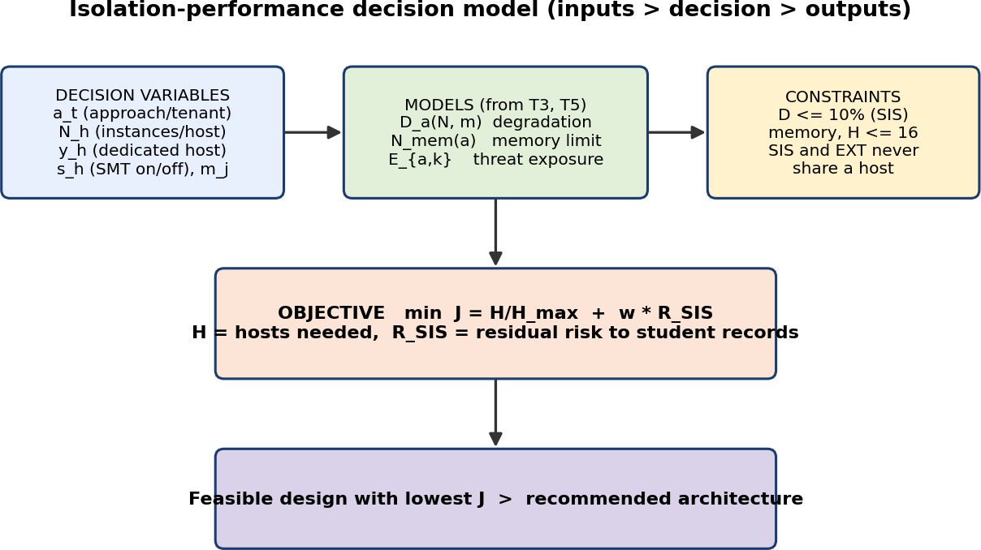
TASK 6: Formulate the Isolation–Performance Trade-off (3 Marks)

Figure 11: Structure of the decision model: variables, models, constraints, objective

Decision variables
    - a_t ∈ {KVM, Docker, gVisor, Kata}: approach chosen for tenant class t ∈ {SIS, LMS, EXT, DEPT}.
    - N_t: instances per host for class t; H_t: number of hosts in the pool of class t.
    - z_t ∈ {0,1}: 1 if class t shares hosts with a less-trusted class (external tenants); y_h ∈ {0,1}: host dedicated to one tenant class.
    - s_h ∈ {0,1}: SMT enabled on host h; m_j ∈ {0,1}: mitigation j applied (KPTI, encrypted migration, image signing, memory encryption).

Models taken from Tasks 3 and 5
D_a(N, m) = 1 − (1 − N·R·c_io/P)(1 − σ(r))(1 − o_virt,a)(1 − Σ_j m_j·δ_j) N_mem,a = floor((M − M_res,a)/(m + m_ovh,a))
R_t = (Ē_a / 5) · (1 + γ·z_t) · Π_j (1 − m_j·ε_j) Ē_a = Σ_k w_k · E_{a,k}
E_{a,k} is the exposure score of Task 5 (Fig. 10). Weights w = (0.20, 0.15, 0.20, 0.10, 0.10, 0.10, 0.15) for T1…T7 emphasise the threats that cross a tenant boundary. This gives Ē = 3.40 (KVM), 4.05 (Docker), 2.85 (gVisor), 2.85 (Kata). γ = 1 doubles the risk when the tenant shares hosts with untrusted tenants. ε_j is the risk reduction of mitigation j (assumed 0.6 combined for SMT-off + encrypted migration + signing).

Objective and constraints
minimise J = H / H_max + w · R_SIS (H = Σ hosts used, H_max = 16, w = 1)

# | Constraint | Origin
C1 | D_a(N_t, m) ≤ 0.10 for SIS and LMS; ≤ 0.20 for EXT | SLO (Task 3 model)
C2 | N_t · (m + m_ovh,a) ≤ M − M_res,a | Memory model
C3 | Σ_t H_t ≤ 16 (available hosts) | EduCloud inventory
C4 | z_SIS = 0 (no co-location of student records with external tenants) | Data-protection regulation (Task 12)
C5 | Peak demand: N_t · v · u_peak ≤ P · (1 − D_a) (u_peak = 3 × u_normal, capped at 1) | Registration week (3×)

# | Constraint | Origin
C6 | R_SIS ≤ R_max; T6 and T7 mitigations mandatory for classes holding student data | Task 5 threat model

  - Illustrative evaluation of candidate designs (SIS + external workload)
Workload: SIS/LMS = 144 VMs × 4 vCPU at u_peak = 0.75 (432 core-demand, 1,152 GB); external Spark = 60 executors × 4 vCPU at u = 0.9 (216 cores, 960 GB).

Design | Hosts H | D at density % | R_SIS | J | C4 satisfied?
D1 all Docker, shared hosts | 11 | 6.3 | 0.97 | 1.66 | No (z=1)
D2 all KVM, shared hosts | 12 | 9.9 | 0.82 | 1.57 | No (z=1)
D3 all Kata, shared hosts | 12 | 9.9 | 0.68 | 1.43 | No (z=1)
D4 hybrid pools: SIS on KVM, external on Kata | 12 | 9.9 / 9.9 | 0.41 | 1.16 | Yes (z=0)

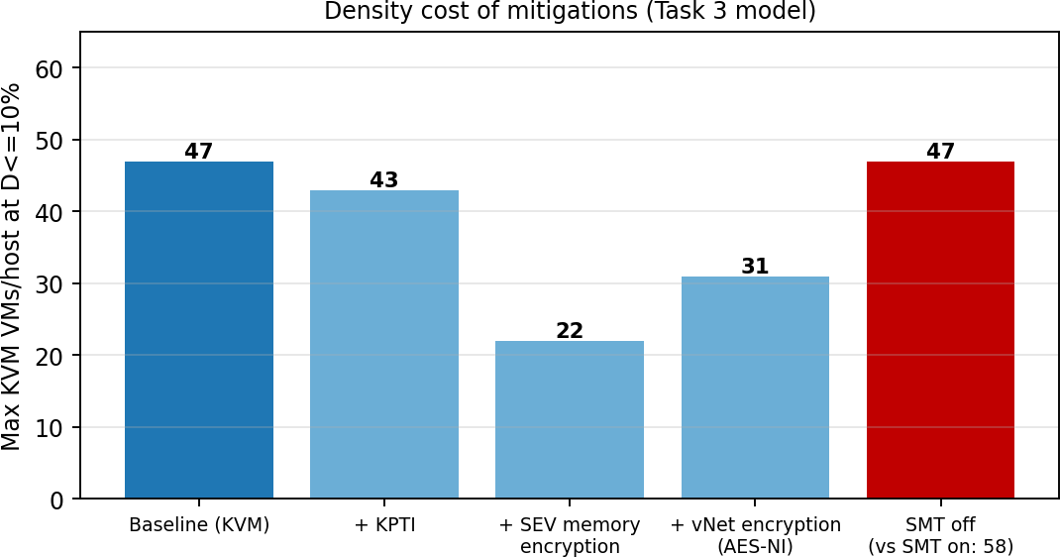
TASK 7: Evaluate Mitigation Strategies (4 Marks)
Result: designs D1–D3 all violate constraint C4 (shared hosts), so they are infeasible whatever their J. D4 (pools: SIS on KVM, external on Kata) minimises J among feasible designs (J = 1.16) and uses the same 12 hosts. This formulation is what drives the Task 11 and Task 12 decisions.

Figure 12: Density cost (max KVM VMs per host at D ≤ 10%) of each mitigation, from the Task 3 model

Mitigation | Threat addressed / why applicable | Residual risk | Cost (Task 3 model) | Acceptable for SIS?
M1 SMT off (or core scheduling) | T3: removes sibling-thread cache/L1TF channels | Cross-core (L3, memory-bus) channels remain | Aggregate throughput −20% relative to SMT-on (1.25× → 1.0×). KVM  density 58 → 47 per host; 16 hosts  still give 752 VMs ≥ 400 | Yes: capacity is ample
M2 Kernel page-table isolation (KPTI) +  microcode in guests and host | T3 (Meltdown class), T1 kernel-memory reads | Spectre v2 variants need retpoline / IBRS | Syscall 0.2 → 0.3 µs: +50,000 × 0.1 µs = +0.5% D. KVM SLO density 47 → 43; at N = 25 D rises 7.5% →  7.9% | Yes

Mitigation | Threat addressed / why applicable | Residual risk | Cost (Task 3 model) | Acceptable for SIS?
M3 Dedicated host pools for SIS (no external co-location) | T1–T3 from untrusted tenants; makes isolation demonstrable | Insider and same-pool threats remain | No change in D, but reserved capacity: Pool A runs about 28% utilised outside registration week (peak is 3×) | Yes: required by regulation
M4 Sandboxed runtime for containers (gVisor or Kata) | T1, T2 for container tenants | Residual VMM/Sentry bugs; side channels | Docker → Kata: D at N = 25 from 3.6% to 9.7%; density 62 → 27 at  10% SLO. gVisor: D 14.4%, only  meets 20% SLO | Yes for external tenants; not needed for SIS VMs
M5 Image signing (cosign/GPG) + registry with RBAC | T5, T4 (known-good golden images) | Compromised signing key; supply-chain bugs | Verify 8 GB image at ≈ 2 GB/s ≈ 4 s once per deployment; no runtime cost | Yes
M6 Encrypted live migration + micro-segmentation (TLS/IPsec, VXLAN ACLs) | T6, T7 | Endpoint compromise; metadata leakage | Migration bandwidth 1.56 → ≈ 1.33 GB/s with AES-NI: T = 8/(1.33 − 0.4) = 8.6 s vs 6.9 s (+25%).  Network encryption ≈ 2% CPU: density 47 → 31 | Yes, if migration is scheduled outside peak
M7 Hardware memory encryption (AMD SEV / Intel TDX) | T1/T3 from the hypervisor itself, T6 | Side channels via cache; firmware trust | +3% memory-bound overhead: density 47 → 22. At N = 25 D = 10.2%, marginally above SLO | Conditional: use at N ≤ 20 or relax SLO

TASK 8: Implement and Test (4 Marks)
Recommended mitigation set for SIS: M1 + M2 + M3 + M5 + M6 (cumulative D at N = 20 ≈ 9.2%, inside the SLO). M7 is held in reserve for the most sensitive tenants. M4 is applied to every container-based external tenant.
How to use this section: the environment, commands and scripts below are complete and reproducible. Run them on your machine to obtain your own measurements; Task 9 and Task 10 contain model-predicted values and empty "Measured" cells for your results. Do not submit predicted values as measurements.

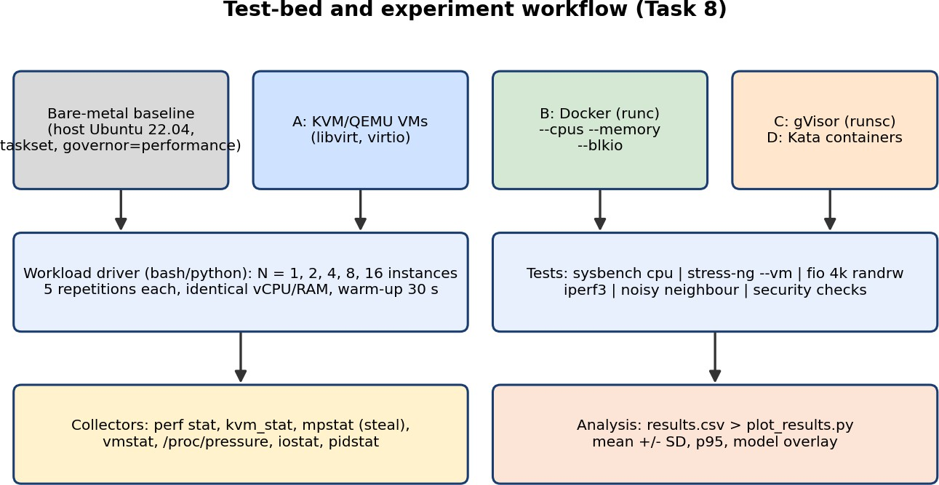

Figure 13: Test-bed architecture and experiment workflow

Test-bed description

Item | Specification (adjust to your hardware and state it)
Host | Laptop/desktop, 16 logical CPUs, 32 GB RAM, NVMe SSD, Ubuntu 22.04 LTS, governor = performance, turbo disabled for repeatability
Scale | N = 1, 2, 4, 8, 16 instances, each 2 vCPU and 1.5 GB RAM (model scaled: P = 16, v = 2). If the machine is smaller, reduce the maximum N and state it
Nested virtualization | If the host is itself a VM, enable nested KVM (kvm_intel nested=1) and document it; expect larger exit cost
Stack | KVM/QEMU + libvirt (A), Docker 24+ with runc (B), gVisor runsc (C), Kata Containers (D)
Tools | sysbench, stress-ng, fio, iperf3, sysstat (mpstat, iostat), perf, kvm_stat, python3 + pandas + matplotlib
Repetitions | 5 per (approach, N, test); 30 s warm-up discarded; report mean ± SD and p95

Installation
sudo apt update
sudo apt install -y qemu-kvm libvirt-daemon-system virtinst cloud-image-utils \
docker.io sysbench stress-ng fio iperf3 sysstat linux-tools-generic python3-pandas python3-matplotlib sudo usermod -aG libvirt,docker $USER
# gVisor (runsc) - follow https://gvisor.dev/docs/user_guide/install/ then: sudo runsc install && sudo systemctl restart docker
# Kata containers - e.g. snap install kata-containers --classic (or kata-deploy on k8s) # Verify hardware virtualization
egrep -c '(vmx|svm)' /proc/cpuinfo ; lsmod | grep kvm

Creating N identical instances per approach
# ---- A: KVM VMs (cloud-init + backing image) ----for i in $(seq 1 $N); do
qemu-img create -f qcow2 -b jammy.img -F qcow2 vm$i.qcow2 virt-install --name vm$i --vcpus 2 --memory 1536 --import \
--disk vm$i.qcow2,bus=virtio --disk seed.iso,device=cdrom \
--network network=default,model=virtio --os-variant ubuntu22.04 --noautoconsole done
# ---- B: Docker (runc) ----for i in $(seq 1 $N); do
docker run -d --name c$i --cpus=2 --memory=1536m ubuntu-bench sleep infinity done
# ---- C: gVisor ----
for i in $(seq 1 $N); do
docker run -d --runtime=runsc --name g$i --cpus=2 --memory=1536m ubuntu-bench sleep infinity done
# ---- D: Kata ----
for i in $(seq 1 $N); do
docker run -d --runtime=kata-runtime --name k$i --cpus=2 --memory=1536m ubuntu-bench sleep infinity done
# start-up time: wrap each create with date +%s.%N before and after "ready"

Workloads (identical for every approach)

Test | Command (run inside every instance, in parallel) | Metric
CPU-bound | sysbench cpu --threads=2 --time=60 run | events/s, latency avg/p95
Memory-intensive | stress-ng --vm 1 --vm-bytes 1G --vm-method all --timeout 60s --metrics-brief | bogo ops/s
Disk I/O | fio --name=rr --rw=randrw --bs=4k --iodepth=16 --direct=1 --size=1G --runtime=60 --time_based --output-format=json | IOPS, clat mean, p95
Network | iperf3 -c $SERVER -t 60 -P 2 -J (server on the host or another machine) | Gbps, retransmits
Context switches / exits | pidstat -w 1 60 ; perf stat -e context-switches,cpu-migrations -a sleep 60 ; sudo kvm_stat -1 (A, D) | switches/s, VM exits/s

Test | Command (run inside every instance, in parallel) | Metric
Steal time | mpstat 1 60 (column %steal inside VM) | % steal

Driver script (reproducibility)
#!/usr/bin/env bash
# run_all.sh - usage: ./run_all.sh <approach> (A|B|C|D)
APPROACH=$1; mkdir -p results for N in 1 2 4 8 16; do
./create_instances.sh $APPROACH $N for REP in 1 2 3 4 5; do
for TEST in cpu mem disk net; do for i in $(seq 1 $N); do
./exec_in_instance.sh $APPROACH $i "$TEST" > results/${APPROACH}_N${N}_r${REP}_${TEST}_$i.json & done; wait
done done
./destroy_instances.sh $APPROACH $N done

Noisy-neighbour experiment
One victim instance runs the web/DB-like load (fio 4k randread, QD1, for latency; sysbench for CPU). N − 1 neighbours run a storm: stress-ng --cpu 2 --io 2 --vm 1 and fio --rw=randwrite --bs=64k --iodepth=64.
Compare victim p95 latency and throughput with the storm off and on, for all four approaches, same allocation and repetitions. Prediction (Fig. 14b): Docker worst, Kata best.

Security validation (at least one property, three are listed)
# 1) Kernel sharing: container shares host kernel, VM and Kata do not, gVisor shows a Sentry kernel uname -r # host
docker run --rm ubuntu uname -r # same as host -> shared kernel
docker run --rm --runtime=runsc ubuntu dmesg | head # synthetic Sentry boot messages virsh console vm1 (uname -r) # different guest kernel
# 2) Namespace / cgroup / seccomp isolation
docker run --rm ubuntu sh -c 'ls -l /proc/self/ns; cat /sys/fs/cgroup/memory.max; grep Seccomp /proc/self/status' docker run --rm --pids-limit=50 ubuntu sh -c 'for i in $(seq 100); do sleep 60 & done' # blocked by pids.max
# 3) Mitigation status and effect (SMT, KPTI, Spectre) grep . /sys/devices/system/cpu/vulnerabilities/*
cat /sys/devices/system/cpu/smt/active ; echo off | sudo tee /sys/devices/system/cpu/smt/control dmesg | grep -i 'page tables isolation'
Record the output as evidence (screenshots). Re-run the CPU and I/O tests after each mitigation is enabled to obtain the "with mitigation" results required in Task 9.

TASK 9: Record Experimental Performance (3 Marks)
Predicted columns are produced by the Task 3 model for the test-bed (P = 16, v = 2, R = 3,000 ops/s). Fill the Measured columns with your own mean ± SD from the 5 repetitions (python script below does the aggregation and plotting).

Table: per-instance throughput as % of bare-metal share

N | KVM  pred. | KVM  measured | Docker pred. | Docker measured | gVisor pred. | gVisor measured | Kata pred. | Kata measured
1 | 94.9 | ± | 97.9 | ± | 89.8 | ± | 92.9 | ±
2 | 94.7 | ± | 97.9 | ± | 89.6 | ± | 92.8 | ±
4 | 94.5 | ± | 97.7 | ± | 89.2 | ± | 92.6 | ±

N | KVM  pred. | KVM  measured | Docker pred. | Docker measured | gVisor pred. | gVisor measured | Kata pred. | Kata measured
8 | 94.1 | ± | 97.4 | ± | 88.4 | ± | 92.1 | ±
16 | 92.9 | ± | 96.6 | ± | 86.5 | ± | 90.7 | ±

Other metrics to record (expected ranges for comparison)

Metric | KVM | Docker | gVisor | Kata | Your measured values
Start-up time per instance | 15–40 s (full guest boot) | < 1 s | 1–3 s | 1–4 s
Memory footprint overhead / instance | ≈ 0.3–0.4 GB  (QEMU + guest kernel) | tens of MB | ≈ 100–150 MB | ≈ 150–250 MB
Mean and p95 latency (fio 4k) | record | record | record | record
CPU steal (%), context switches/s, VM exits/s | steal, exits/s from kvm_stat | no steal/exits | host threads only | as KVM
Degradation vs bare metal | record | record | record | record
With mitigation (SMT off, KPTI) | record | record | record | record
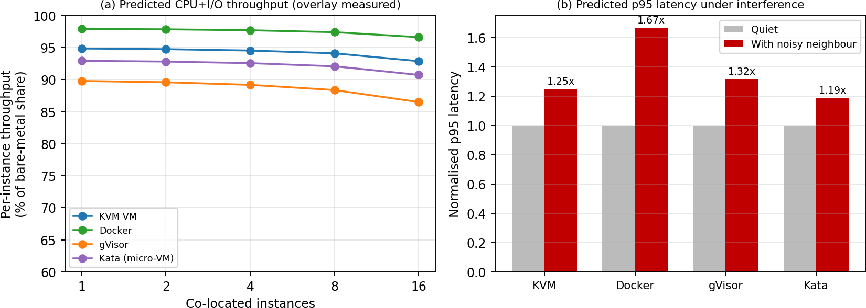
Figure 14: (a) Predicted throughput vs instances (overlay your measured points); (b) predicted p95 latency under a noisy neighbour

Aggregation and plotting script
# plot_results.py - expects results.csv: approach,N,rep,test,throughput,p95_ms import pandas as pd, matplotlib.pyplot as plt
df = pd.read_csv('results.csv')
g = df.groupby(['approach','N','test']).agg(mean=('throughput','mean'),sd=('throughput','std'), p95=('p95_ms','mean')).reset_index()
base = g[g.approach=='bare'].set_index(['N','test'])['mean']
g['pct_of_baseline'] = g.apply(lambda r: 100*r['mean']/base[(r.N,r.test)], axis=1) fig,ax = plt.subplots(1,2,figsize=(10,4))
for a,s in g[g.test=='cpu'].groupby('approach'):
ax[0].errorbar(s.N, s.pct_of_baseline, yerr=100*s.sd/base[(s.N.iloc[0],'cpu')], marker='o', label=a) ax[0].set_xscale('log',base=2); ax[0].set_xlabel('instances'); ax[0].set_ylabel('% of bare metal'); ax[0].legend() for a,s in g[g.test=='disk'].groupby('approach'): ax[1].plot(s.N, s.p95, marker='o', label=a)
ax[1].set_xlabel('instances'); ax[1].set_ylabel('p95 latency (ms)'); plt.tight_layout(); plt.savefig('results.png',dpi=200)
Report mean ± SD for every cell. Use at least: one table (9.1) and two graphs (throughput vs N, and p95 latency under interference).

TASK 10: Compare Theory with Experiment (4 Marks)

Method of comparison
ε = (measured − predicted) / predicted × 100%
accept the model if |ε| ≤ 15% and the trend (ordering
and slope) matches

Quantity | Predicted (model) | Measured | ε % | Trend agrees?
KVM degradation at N = 16 | from Table 9.1
Docker degradation at N = 16 | from Table 9.1
gVisor degradation at N = 16 | from Table 9.1
Kata degradation at N = 16 | from Table 9.1
p95 latency ratio under noisy neighbour (KVM / Docker / gVisor / Kata) | 1.25 / 1.67 / 1.32 /  1.19
Effect of SMT off / KPTI on throughput | −20% (aggregate) /  −0.5%

Expected agreement and plausible causes of deviation

Observation you may see | Plausible cause | How to confirm / correct the model
KVM degradation higher than predicted | Nested virtualization or laptop VM: a VM exit costs 5–10 µs, not 1.5 µs | Measure exits/s with kvm_stat; refit t_exit  = (loss)/(exits/s)
Docker nearly 0% degradation for CPU tests | No trapping; model's 2% accounts for I/O/overlayfs only | Separate CPU-only and I/O tests; calibrate o_virt per test
gVisor much worse on I/O than on CPU | Syscall + Gofer RPC path is not a simple multiple of 2 µs | Count syscalls with strace -c; refit t_gv
Measured throughput lower at N  = 16 than model | Thermal throttling, shared L3 cache, SMT sibling contention, scheduler migrations | Disable turbo, pin vCPUs, compare SMT on/off
Disk results look better than predicted | Guest/host page cache hides device latency | Use direct=1 and drop caches between runs
Kata slower than KVM in file tests | virtio-fs/9p extra copies (unmodelled path) | Add c_fs term; compare virtio-blk vs virtio-fs
Variation between repetitions  >10% | Background tasks, frequency scaling | Use more repetitions; report SD

Scaling conclusion (to be confirmed by your data)
The model predicts that Docker scales best (no exits, lowest per-I/O cost, 62 per host), KVM next (47 per host at 10%), Kata limited at 27 per host by the virtio-fs path, and gVisor worst on syscall-heavy loads. If your measured slopes of degradation vs N follow the same ordering, the model is validated; any approach whose slope is steeper than predicted indicates an unmodelled shared resource (queue, lock, cache).

Does any result change the Task 5 security conclusions?
    - Kernel-sharing check (8.7): confirming that containers report the host kernel version supports the high T1/T2 exposure of Docker.
    - Noisy-neighbour result: if Docker's p95 degrades more than the VM approaches, the exposure of Docker to availability attacks (and to timing side-channels) is confirmed. If gVisor or Kata show less interference than KVM, their ranking in the heat map improves.

    - Mitigation test: if SMT-off costs less than the predicted 20% on your CPU, M1 becomes even more attractive; if KPTI costs much more than 0.5% on syscall-heavy gVisor, revisit M2 for gVisor.

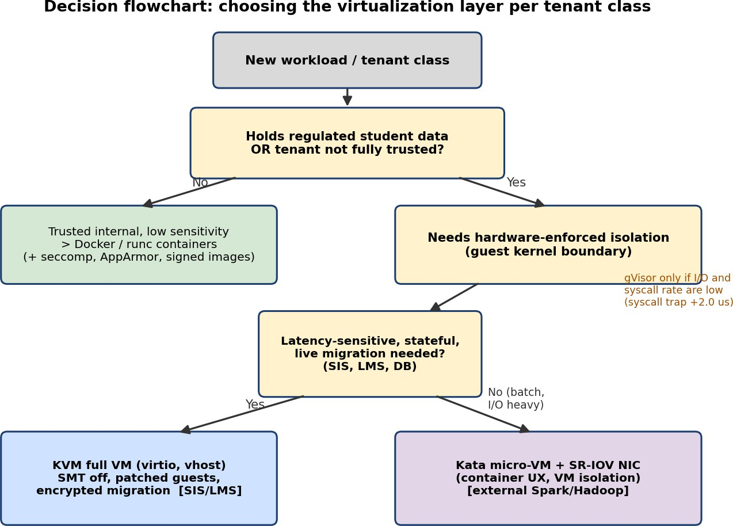
TASK 11: Recommend and Defend the Final Architecture (4 Marks)

Figure 15: Decision flowchart for choosing the virtualization layer per tenant class

Recommendation
Recommended architecture for the SIS and LMS: hardened KVM full VMs (Approach A) with virtio/vhost, SMT disabled, patched guests built from signed golden images, encrypted live migration and tenant micro-segmentation, operated at ≈ 20–25 VMs per host. Trusted, stateless internal services (LMS web tier, dev/test) may run in Docker containers on separate hosts.

Criterion | A: KVM VM | B: Docker | C: gVisor | D: Kata
Modelled performance (SIS typical, N = 25) | D = 7.5% (meets SLO) | D = 3.6% | D = 14.4% (fails 10%) | D = 9.7%  (borderline)
Density at 10% SLO | 47 | 62 | 0 | 27
Isolation (Ē, lower is better) | 3.40 | 4.05 | 2.85 | 2.85
Live migration for patching | Mature | Not available | Not available | Limited
Operations (patching, images) | Higher: 1 kernel per VM | Lower: 1 host kernel | Medium | Medium
Verdict for SIS/LMS | Chosen | Rejected: shared kernel for student records | Rejected: syscall overhead | Rejected: live migration/virtio-fs limits

Why it is more appropriate than the alternatives
    - vs Docker: the SIS holds regulated records; a single kernel bug breaks all tenants (T1/T2 = 5). Docker is faster, but the 10% SLO is already met by KVM (7.5%), so the extra speed does not buy anything the SIS needs.
    - vs gVisor: isolation is better than Docker, but o_virt = 10% alone consumes the full SLO budget for syscall-heavy SIS traffic.
    - vs Kata: stronger than KVM on hypervisor attack surface but density is 27 per host and live-migration support is limited, which matters for patching without downtime.

Security posture, residual risk and operations
    - Residual risks: cache side channels across cores (T3), hypervisor/QEMU zero-days (T2), compromised management plane. Controlled by SMT off, rapid QEMU/kernel patching, MFA/RBAC and audit logging.
    - Operational cost: patching ~400 guest kernels is the main cost (T4). Mitigated with a single signed golden image, automated rebuild + rolling live migration, and a sprawl clean-up (the audit found uncontrolled copies).
    - Monitoring: steal time, VM exits/s, p95 latency, host memory pressure; alert at steal > 5% or D > 8%.

Limitations and scalability to several thousand instances

Instances | Hosts at 47 per host (SLO limit) | Hosts at 25 per host (comfortable)
400 | 9 | 16
1000 | 22 | 40
3000 | 64 | 120
5000 | 107 | 200

The design stays practical because per-host density is bounded by the model, not by the hypervisor. Beyond a few hundred hosts the practical limits are management-plane scale (use OpenStack/KubeVirt with cells or multiple clusters), image distribution, patch orchestration and shared-storage bandwidth. Limitation: the model uses assumed parameters (λ_exit, o_ept, R); results must be recalibrated with the Task 8 measurements.

TASK 12: Day-4 Design Challenge – Re-evaluate and Adapt the Design (8 Marks)

Impact Analysis (2 Marks)

Original assumption | Status now | Consequence for performance and threat model
Tenants are trusted (all internal departments) | No longer true: external collaborators run unknown code | Threat model changes from accidental interference to a malicious co-tenant: T1–T3 become realistic, not theoretical
Workload mix: short, bursty web/DB requests | Hours-long Spark/Hadoop batch jobs, CPU at u ≈ 0.9 | Batch jobs never yield CPU: the statistical multiplexing that supports r = 1.56 disappears; steal rises for latency-sensitive VMs
I/O profile: ≈ 10,000 ops/s per instance, light network | ≈ 50,000 ops/s per executor, shuffle traffic up to ~18 Gbps | Backend load N·R·c_io and exit rate grow 5×; one executor can occupy most of a 25 Gbps NIC
Peak = normal | Registration week = 3× load (u: 0.25 → 0.75) | On a 1.56:1 host steal = 1 − 1/(1.56 × 0.75) = 14.7% even before the batch jobs arrive

Original assumption | Status now | Consequence for performance and threat model
Hosts patched in maintenance windows | Live migration of running VMs | Migration traffic competes with shuffle traffic; unencrypted RAM stream of SIS VMs crosses the network (T6)
Isolation is best-effort | Regulation demands demonstrable isolation of student records | Logical separation on shared hosts is not provable; physical/host-level separation is needed (constraint C4)

Effect of mixing batch and latency-sensitive workloads (queueing view). For a shared link with utilisation ρ, mean latency of a small request scales as 1/(1 − ρ). With Spark shuffle using 18 Gbps and SIS using 2 Gbps on one 25 Gbps NIC, ρ = 0.8, so SIS latency is 5× its idle value. On a separate NIC (ρ_SIS = 2/25 = 0.08) it is 1.09×. Mixing therefore harms performance via shared queues and harms security via shared hardware.

Evaluation of the Original Design (2 Marks)
The original design (Task 11) is KVM VMs on shared hosts, ≈ 25 VMs per host. Re-evaluated with the Task 3 model using the new workload:

Check | Result with new conditions | Meets target?
SIS CPU at 3× peak, r = 1.56 | steal = 14.7% (before adding batch load) | No
Spark executors on KVM/virtio, N = 15 per host, R = 50,000 | D = 11.7% (> 10%), backend load 15 × 5×10⁴ × 6 µs =  4.5 cores | No (marginal)
SIS latency while Spark shares NIC | 5× idle (ρ = 0.8) | No
Live migration during peak (B shared with shuffle) | T from 6.9 s to ≫ 10 s as B_mig shrinks; SIS RAM unencrypted | No
Isolation vs untrusted tenant on same host | Separate guest kernels (good) but shared caches, SMT, hypervisor and NIC; cannot be proven physically separate | Inadequate for regulation

Could another architecture do better overall? Alternatives for the external tenants (Task 3 model, N = 15 executors, R = 50,000 ops/s): Docker D = 6.6% but shares the kernel with other tenants (unacceptable for the regulation); gVisor D = 22.7% and ≈ 11 Gbps network ceiling (unsuitable for shuffle); KVM/virtio D = 11.7%; Kata with SR-IOV: D = 9.1%, strong isolation, and container workflow. Kata + SR-IOV is therefore the best architecture for the external tenants.

Adaptation or Redesign (2 Marks)
Decision: MODIFY. Retain KVM VMs for SIS/LMS (they still meet the SLO when not co-located) and add host pools with a stronger, hardware-isolated runtime for external workloads. A complete redesign is not justified: the SIS evidence from Tasks 3–9 is unchanged.

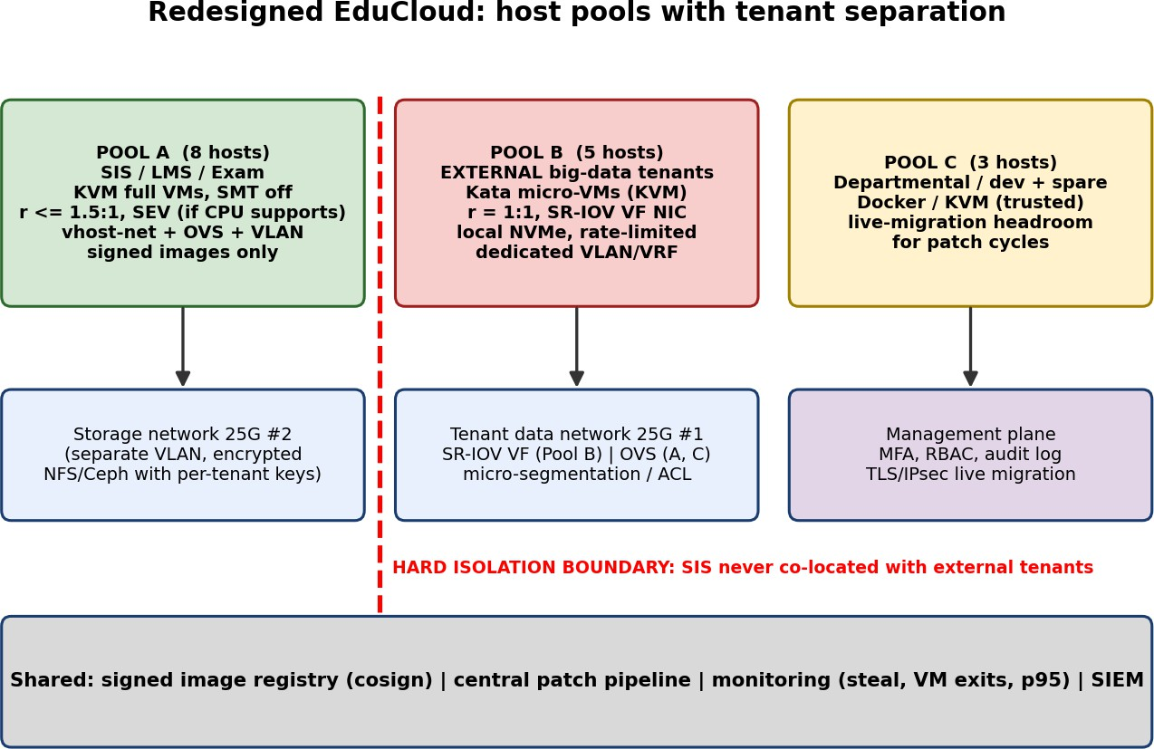

Figure 16: Modified EduCloud: three host pools, separate NICs, hard isolation boundary

What changes
  - Tenant separation by host pools (16 hosts, no new hardware): Pool A (8 hosts) SIS/LMS/exam on KVM; Pool B (5 hosts) external big-data on Kata micro-VMs; Pool C (3 hosts) departmental/dev workloads, migration headroom. SIS and external tenants never share a host (C4).
  - SR-IOV / dedicated NIC for data-intensive jobs: Pool B uses SR-IOV virtual functions on NIC #1 with rate limits; the storage network (NIC #2) is a separate encrypted VLAN. SIS traffic is no longer in the same queues as shuffle.
  - Pool A hardening: SMT off, KPTI, r ≤ 1.5:1, signed images only, vhost-net + OVS with micro-segmentation, encrypted live migration (TLS/IPsec).
  - Patching policy: live migration only outside registration week. Draining one Pool A host moves 144 VMs onto 7 hosts: 20.6 VMs per host. At normal load (u = 0.25) demand is 20.6 cores (fine); at peak
20.6 × 4 × 0.75 = 61.7 cores > 59.7 capacity, so migration at peak is forbidden.

Effect on density, throughput and attack surface
Aspect | Before (shared, 25 VMs/host) | After (pools)
SIS density per host | 25 VMs (r = 1.56) | 18 VMs (r = 1.125); D = 6.7%
SIS CPU at 3× peak | steal 14.7% → SLO violated | demand 18 × 4 × 0.75 = 54 cores ≤ 59.7 capacity;  r·u = 0.84 < 1 so steal = 0
External executors per host | not separated | 15 per host (r = 0.94 ≤ 1:1, 240 GB); 5 hosts give  75 ≥ 60 required
Batch network throughput | shared 25 Gbps, virtio η = 0.92 | SR-IOV η = 0.98 → ≈ 1.63 Gbps guaranteed per executor, bursting to line rate
SIS latency while batch runs | 5× (ρ = 0.8) | ≈ 1.09× (separate NIC)
Attack surface | external tenants on same hosts, caches, NIC, migration network | T1–T3 between SIS and external tenants removed by physical separation; T6 by encryption; T7 by VLAN/VRF

Aspect | Before (shared, 25 VMs/host) | After (pools)
Cost | 16 hosts | 16 hosts (no extra hardware); idle SIS capacity outside peak weeks is the price of isolation

Evidence-Based Defence (2 Marks)
The decision follows from the analysis; each claim is tied to a model result or to an experiment that you will have measured in Tasks 8–10.

Option | SIS performance at 3× peak | SIS latency with batch | Isolation (demonstrable?) | Hosts | Verdict
Retain (all KVM, shared) | steal 14.7% → fails | 5× idle | No: shared hosts | 16 | Rejected
Modify (pools: KVM  + Kata/SR-IOV) | steal 0, D = 6.7% | ≈ 1.09× | Yes: host-level separation | 16 | Chosen
Redesign: everything on Kata | D = 9.7% at 25  VMs; migration limited | shared queues unless SR-IOV | Yes but SIS gains nothing | ≥ 16 | Rejected: costlier, weaker migration
Redesign: external on gVisor | – | – | Good, no hardware boundary | 16 | Rejected: D = 22.7%, ≈ 11 Gbps cap
Redesign: external on Docker | – | – | No (shared kernel) | 16 | Rejected

  - Model (Task 3): the 3× peak pushes r·u above 1 on the original density; reducing SIS density to 18 per host brings r·u to 0.84 and steal to zero. Kata with SR-IOV cuts D from 14.6% (virtio) to 9.1% for I/O-heavy executors.
  - Noisy-neighbour experiment (Task 8/9): predicted p95 inflation 1.25× (KVM), 1.67× (Docker),
1.19× (Kata). A measured Docker figure above KVM/Kata supports rejecting containers for the external tenants and not co-locating on shared kernels.
  - Mitigation experiment (Task 9/10): SMT-off costs about 20% aggregate, but with 8 hosts × 18 VMs the pool still meets peak demand with about 10% headroom (54 vs 59.7 cores); KPTI costs about 0.5%. Hence the mitigation set (M1, M2, M3, M5, M6) is affordable; M7 (memory encryption) is reserved because it would exceed the SLO at 25 VMs per host.
  - Changed conditions: hours-long, I/O-bound jobs call for 1:1 CPU allocation and dedicated NIC resources; 3× peak calls for headroom in Pool A; the regulation requires physical separation. The chosen design satisfies all six constraints C1–C6 with no new hardware.
  - Cost/density trade-off: SIS density falls from 25 to 18 VMs per host and Pool A is only ≈ 28% utilised outside registration week; this is the explicit price of demonstrable isolation, accepted because J = 1.16 is the lowest among feasible designs (Task 6).

Summary of Marks Coverage

Task | Where answered | Evidence provided
1 (5) | Task 1 section | 4 architectures, 4 layered diagrams with trust boundaries, resource-virtualization table, relevance
2 (2) | Task 2 section | Overhead path flowchart + table linking overhead to architecture and scaling
3 (6) | Task 3 section | CPU, memory, I/O, density equations, assumptions, worked examples, tables, 3 graphs
4 (4) | Task 4 section | Best/typical/worst analysis per approach with mechanisms and model numbers

Task | Where answered | Evidence provided
5 (3) | Task 5 section | Attack-surface table, 7 threats, heat map, CIA impact
6 (3) | Task 6 section | Variables, objective, constraints J, evaluation of 4 designs
7 (4) | Task 7 section | 7 mitigations, residual risk, modelled cost, acceptability
8 (4) | Task 8 section | Test-bed, install, scripts, workloads, noisy neighbour, security validation
9 (3) | Task 9 section | Result table, metrics, graph, plotting script (fill measured values)
10 (4) | Task 10 section | Error formula, comparison table, causes, security implications
11 (4) | Task 11 section | Recommendation, comparison, operations, scaling table
12 (8) | Task 12 section | Impact analysis, evaluation, MODIFY design, evidence-based defence

References
  - Felter W. et al., "An updated performance comparison of virtual machines and Linux containers", IEEE ISPASS, 2015.
  - Agache A. et al., "Firecracker: Lightweight Virtualization for Serverless Applications", USENIX NSDI, 2020.
  - Young E. et al., "The True Cost of Containing: A gVisor Case Study", USENIX HotCloud, 2019.
  - Lipp M. et al., "Meltdown: Reading Kernel Memory from User Space", USENIX Security, 2018; Kocher P. et al., "Spectre Attacks", IEEE S&P, 2019.
  - Kata Containers, gVisor, KVM and libvirt official documentation; Intel SDM Vol. 3C (VT-x and EPT).

